***Task 1.Fill in the gaps with the expressions from the box:***

|  |
| --- |
| look into that * speak up * bear with * get back to you * gonna share my screen |

[video 1](https://youtu.be/TshYsRI4GUU?t=337)

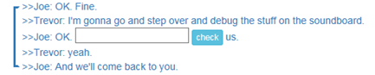

Bear with

[video 2](https://youtu.be/FmsLJHikRf8?t=156)

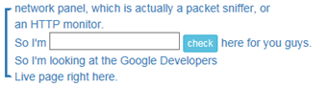

going to share my screen

[video 3](https://youtu.be/txrLRTuniHA?t=385)

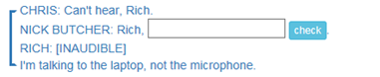

speak up

[video 4](https://youtu.be/-uHlCKcDrzk?t=1567)

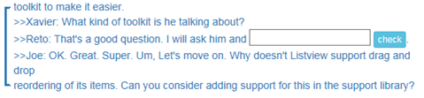

get back to you

[video 5](https://youtu.be/-uHlCKcDrzk?t=2489)

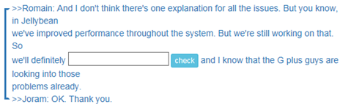

look into that

*Now follow the links and check your answers.*

***Task 2****. Follow the link below and do a test. Before you start, check the settings – the question type should be ‘written’ only (Options 🡪 Question Type). You need to type all the words from the first to the last gap (including all the words in between). Don’t use commas, full stops or question marks.*

<https://quizlet.com/300586630/test>